Linux and Cloud Modulel End Exam Date - 16th March 2024

Shell

1] Write a shell script to check if a given year is leap year or not.

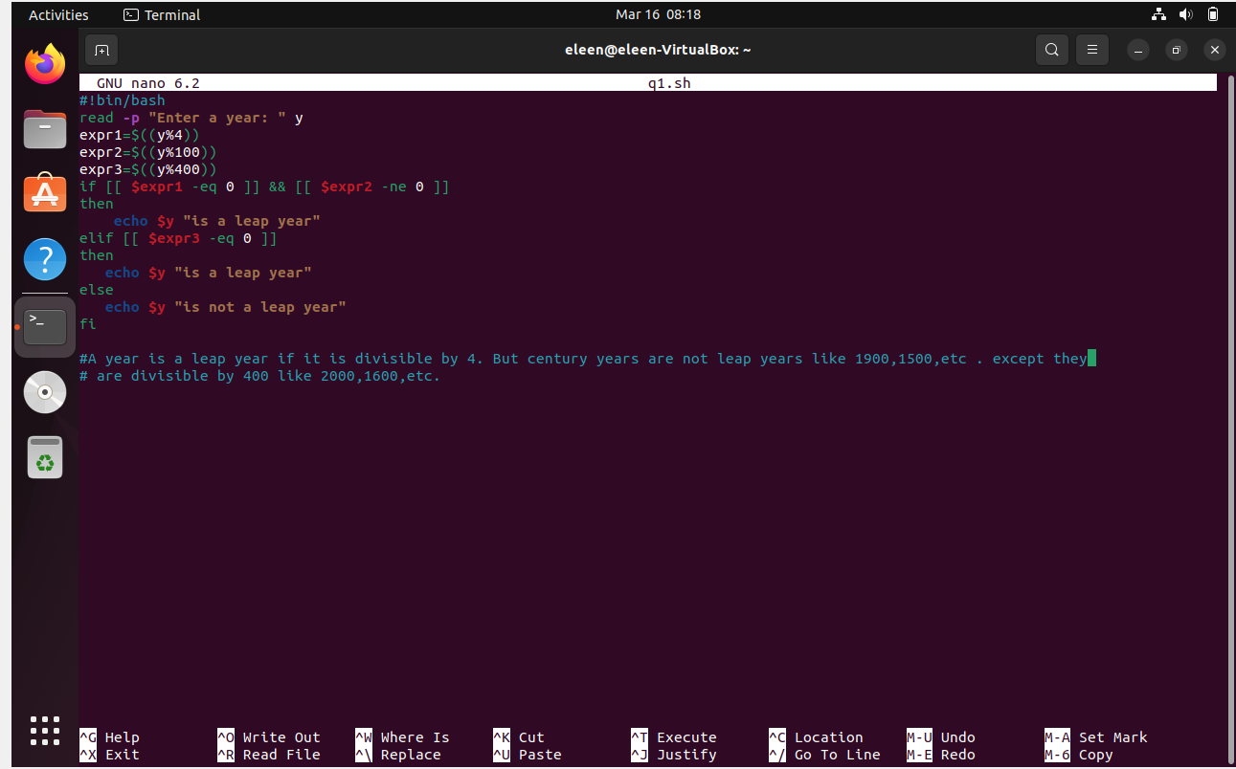

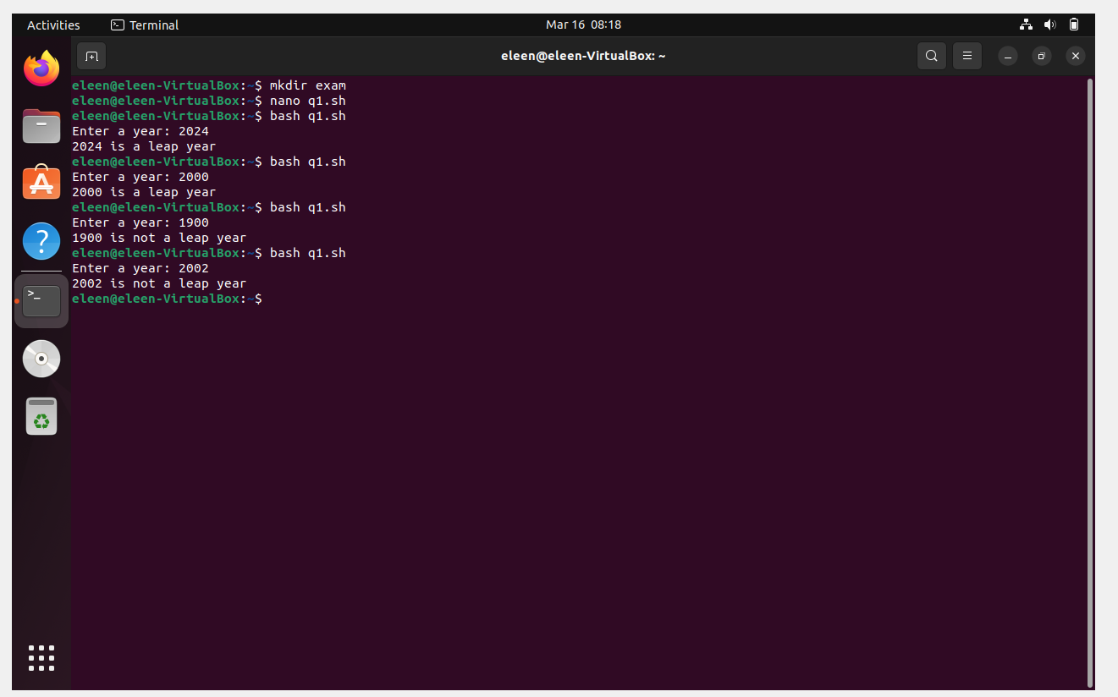

2] Write a shell script to print the fibonacci series upto a certain number entered by user.

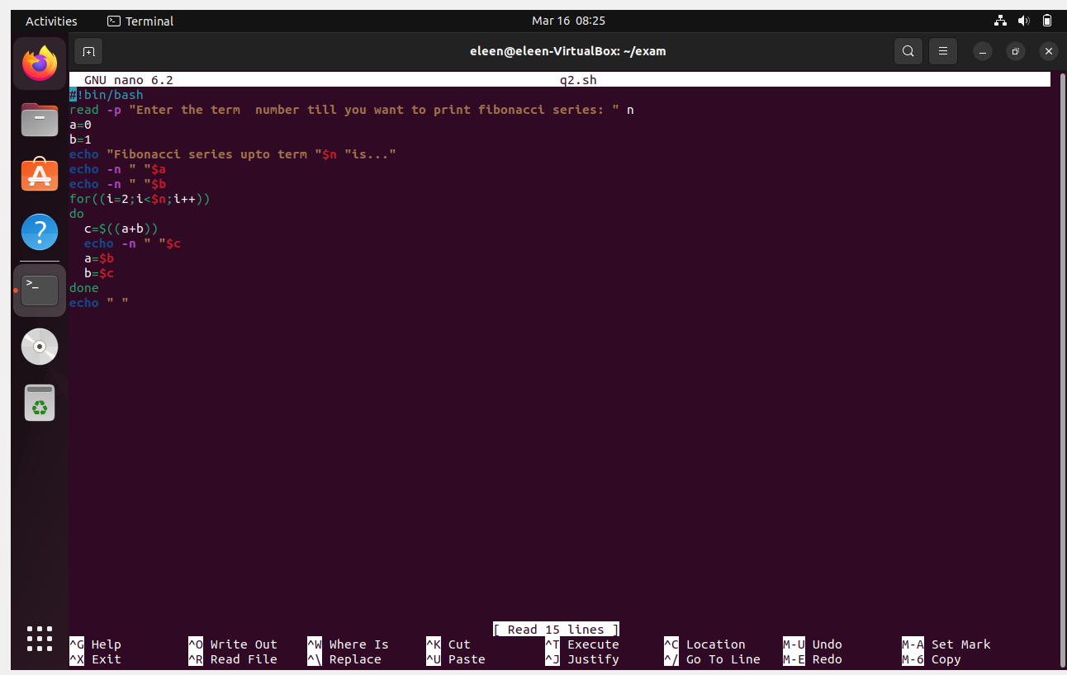

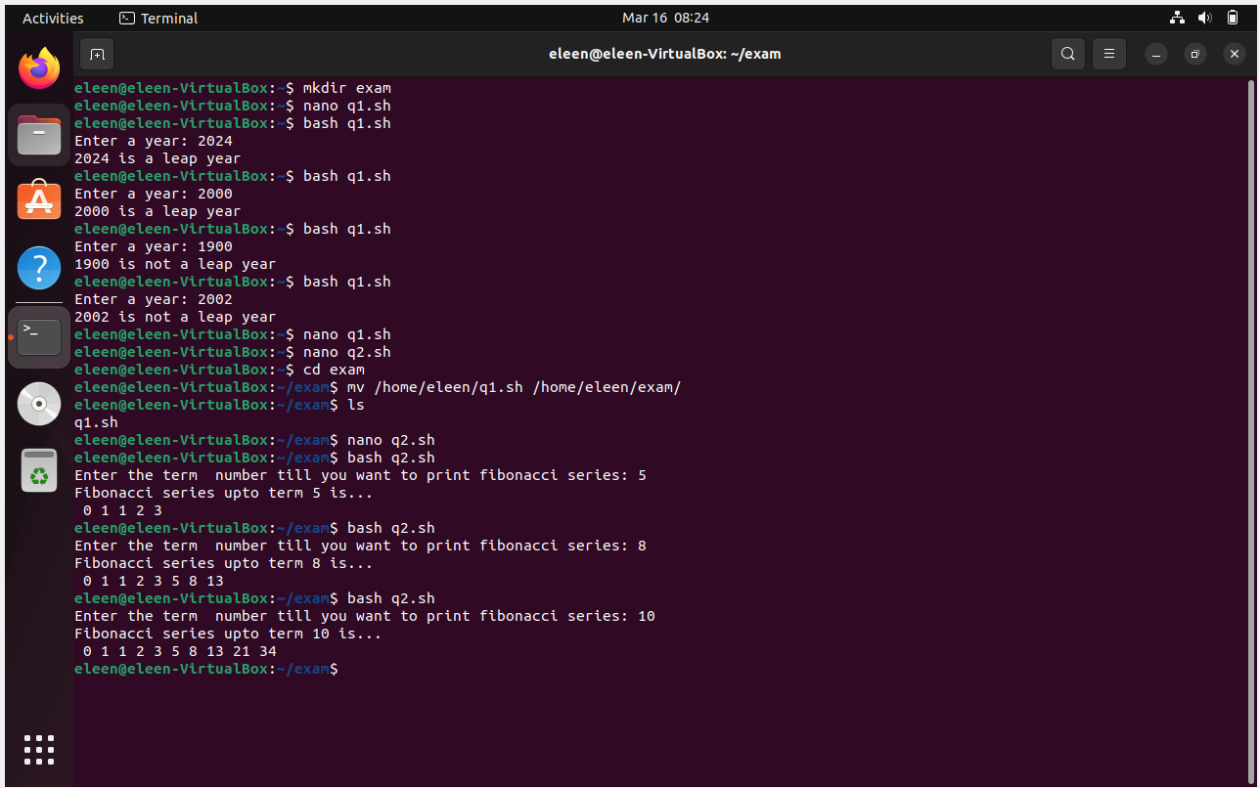

3] Write a Linux directory and file management script that allows user to perform following actions:

* Create a new directory with specified name
* Rename an existing directory with a new name
* Move an existing directory to a new location
* Delete an existing directory
* Create a file name it as file1.txt and create a hardlink to this file

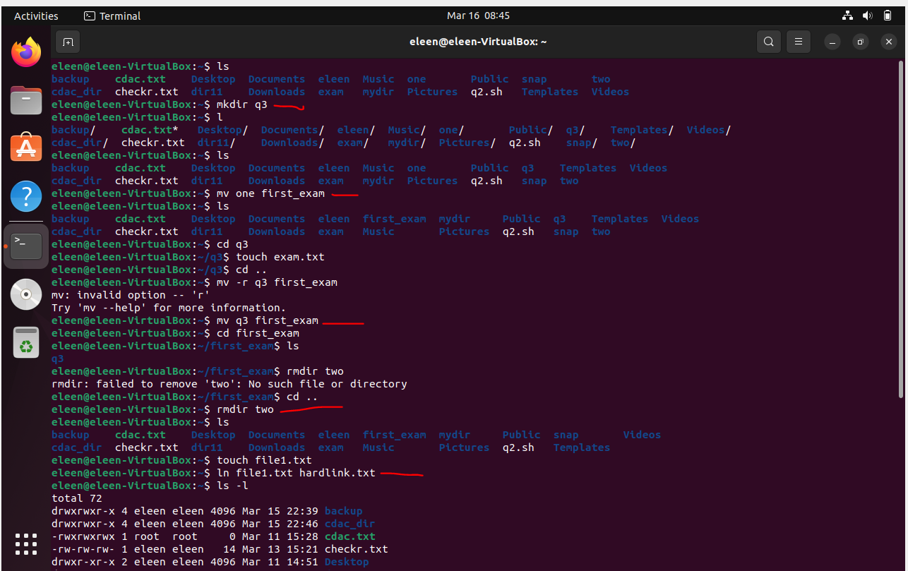

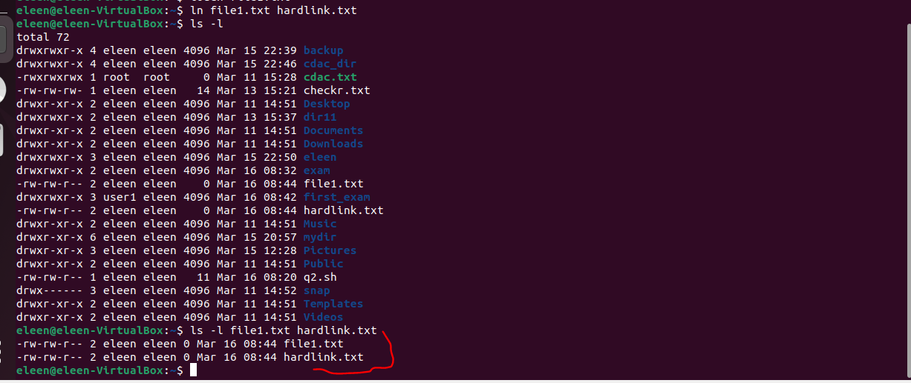

Cloud

1] EC2

Step-1 - Home Console of AWS

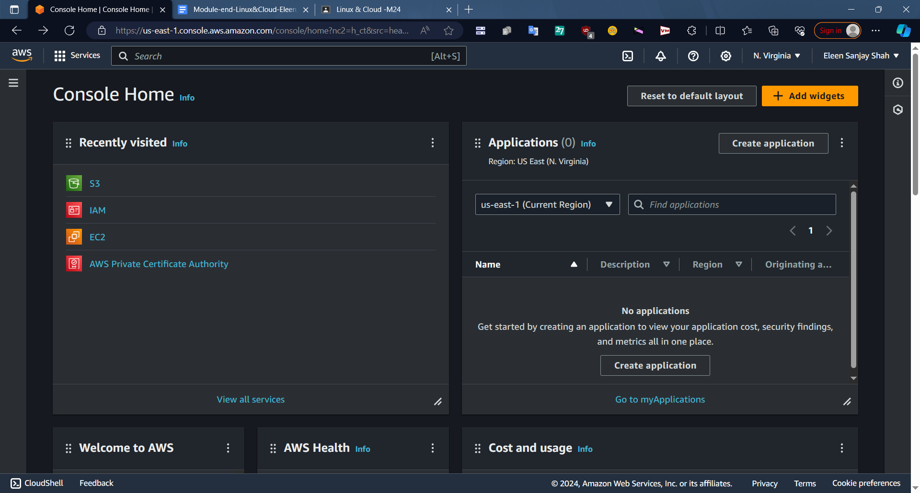

Step2 - Click on Services> EC2 - After clicking you will land up on EC2 Dashboard.

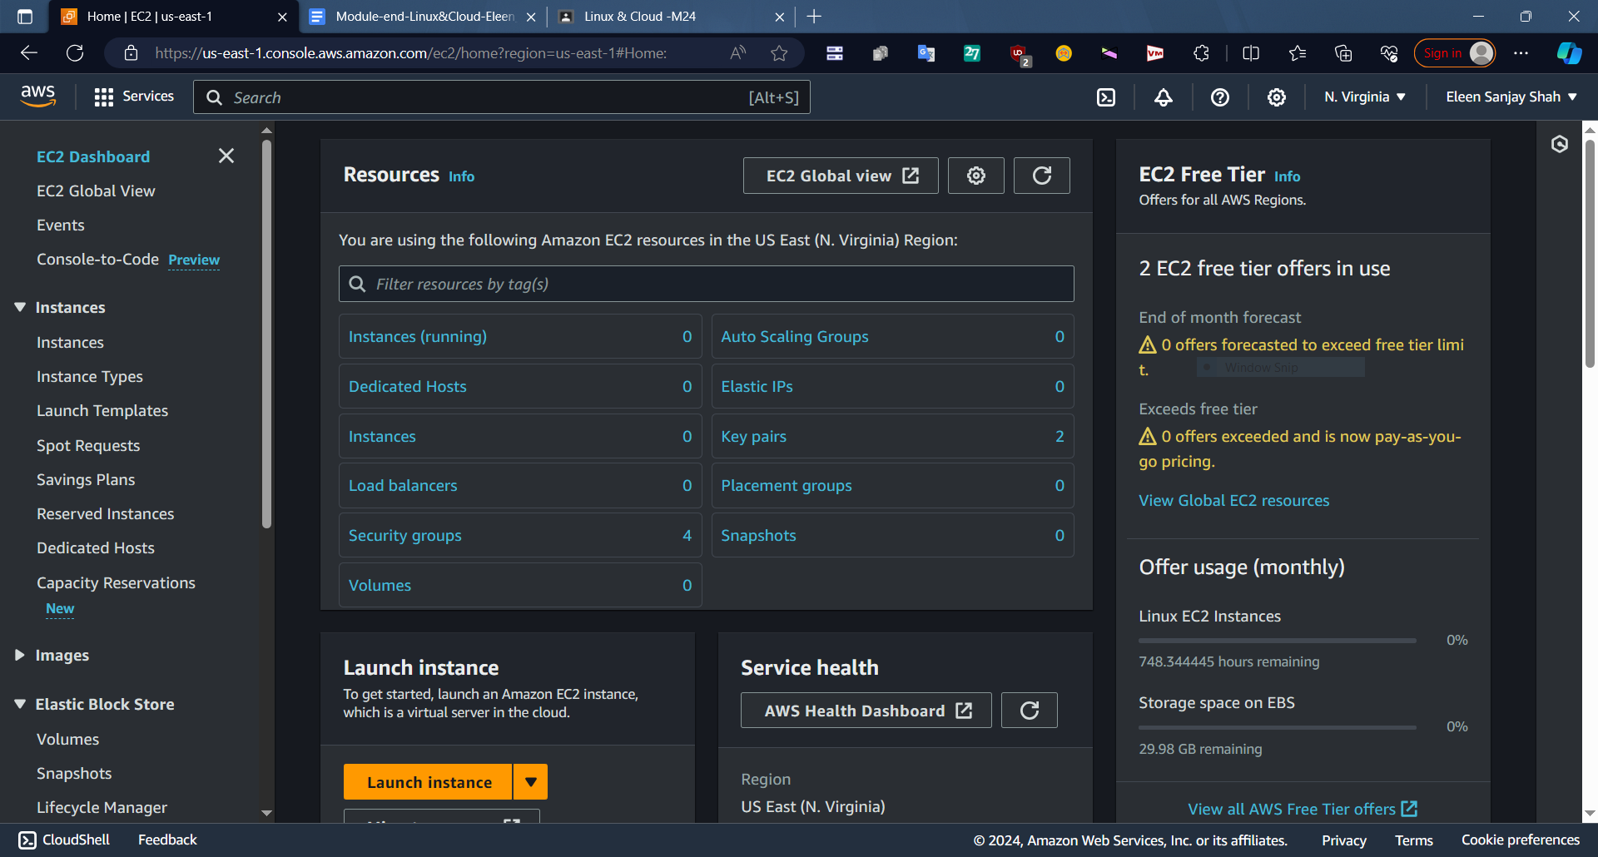

Step3- Click on Launch Instance

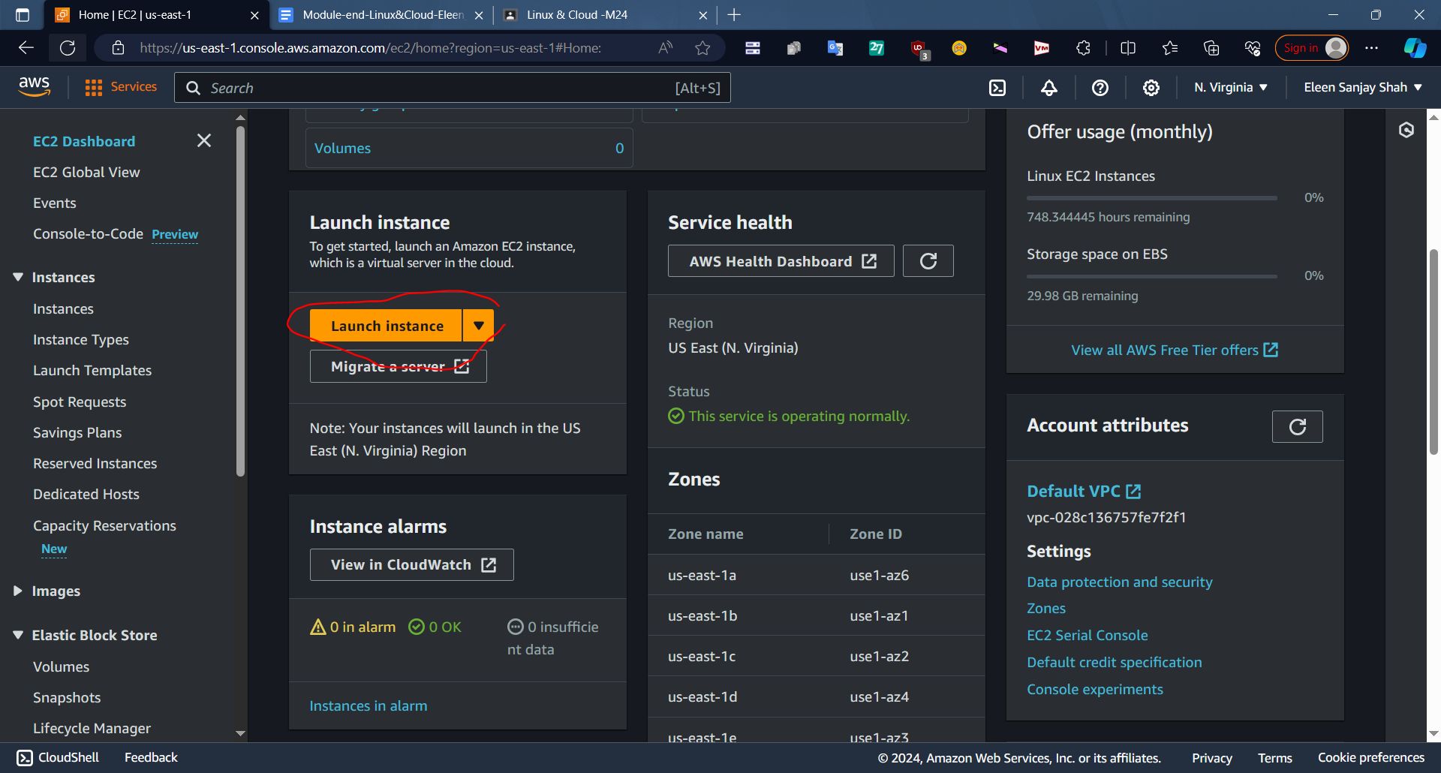

Step 4 - Give a name to your instance

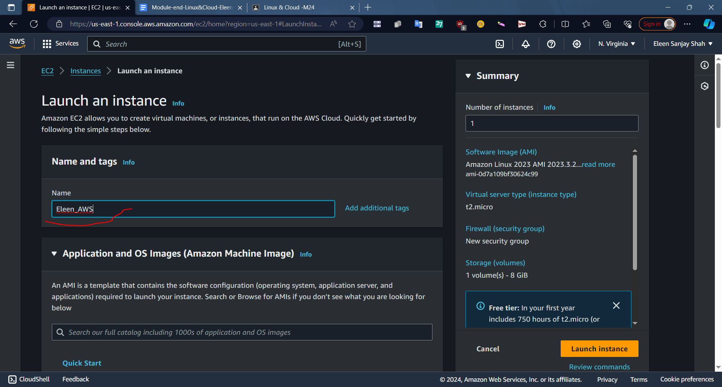

Step 5 - Select OS Image as Linux(by default)

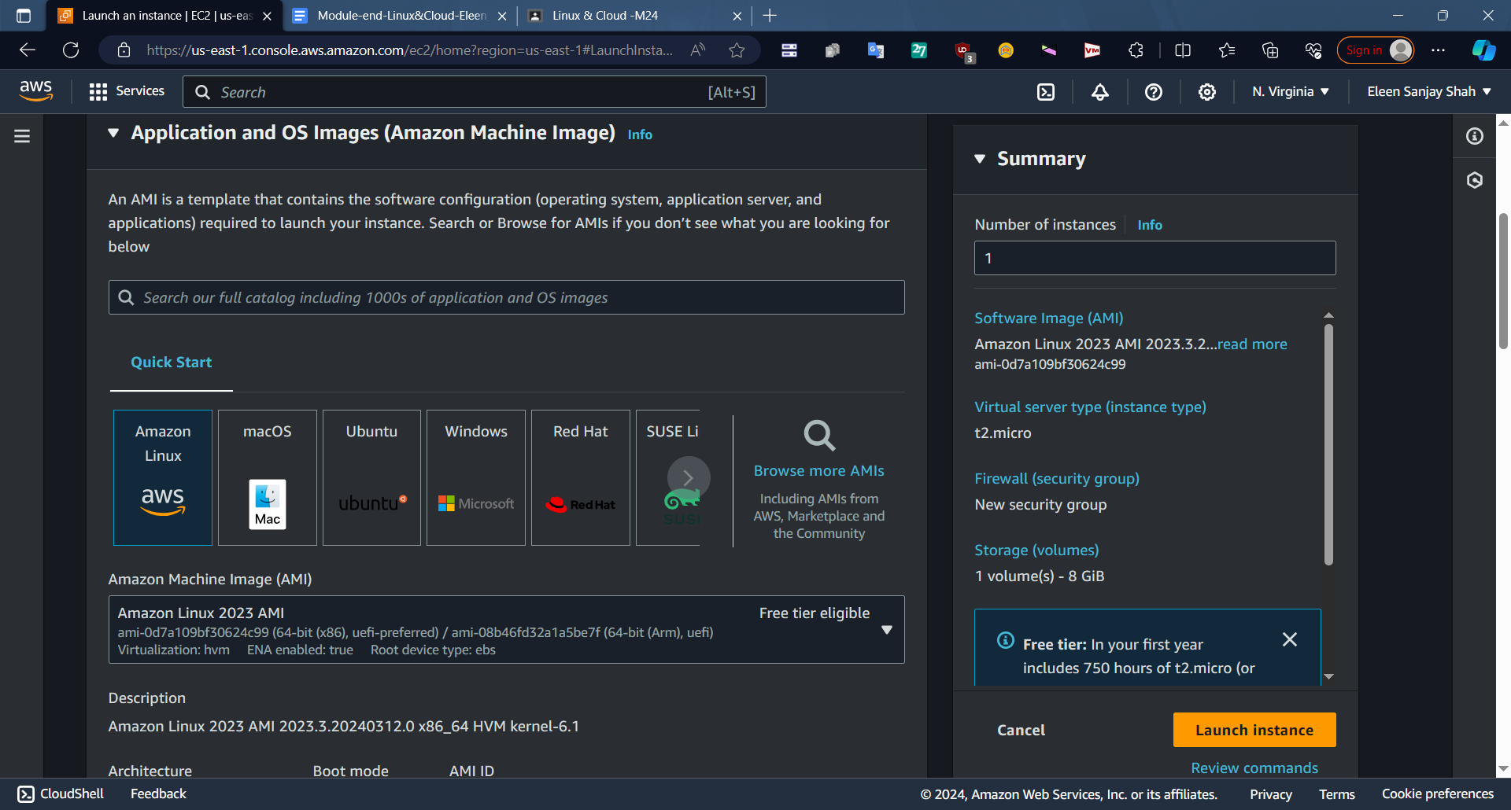

Step 6 - Select Instance type as t2.micro(only select which is free tier eligible)

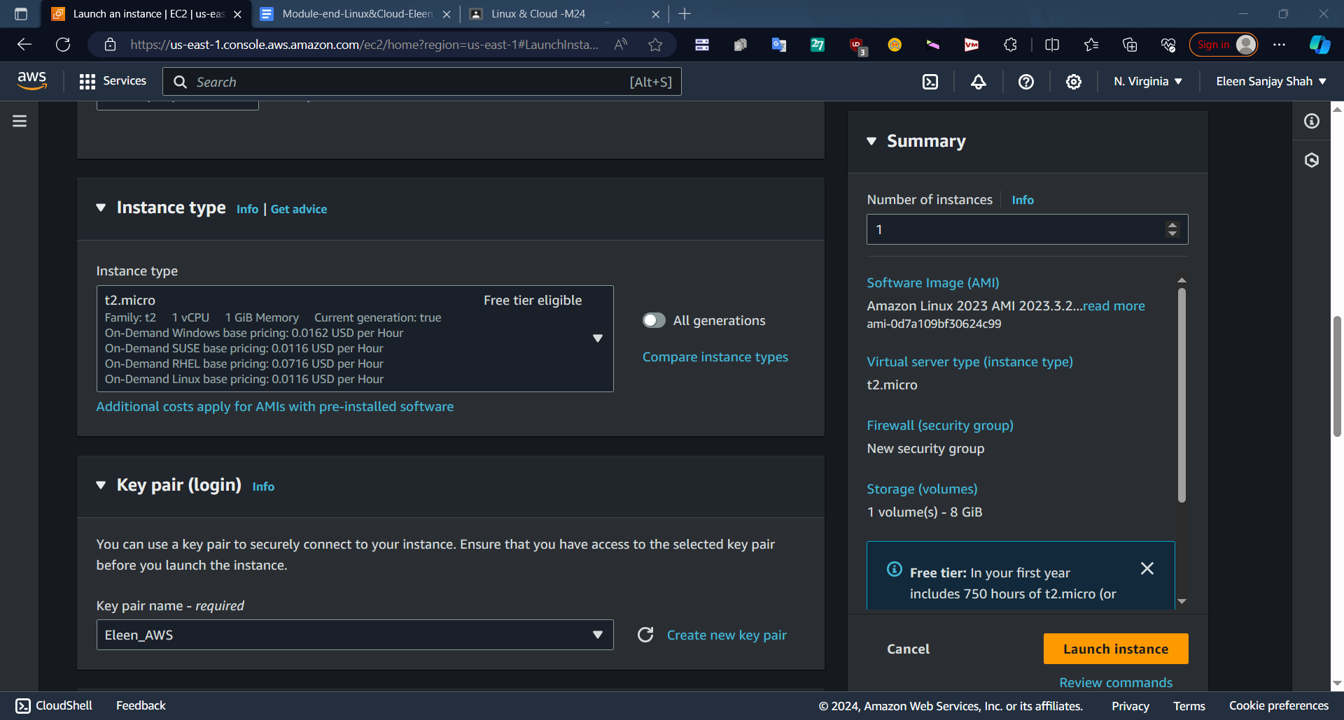

Step 7- Also select key pair which you will use. It should be of .ppk format as we are using putty to connect. Click on Create Key Pair

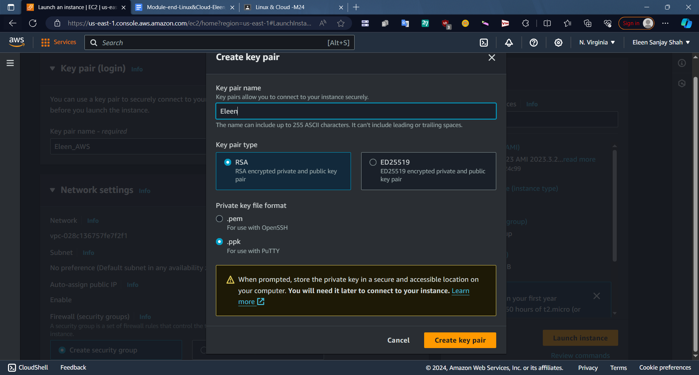

Step 8 - In network settings enable all 3 checkmarks to allow traffic from http.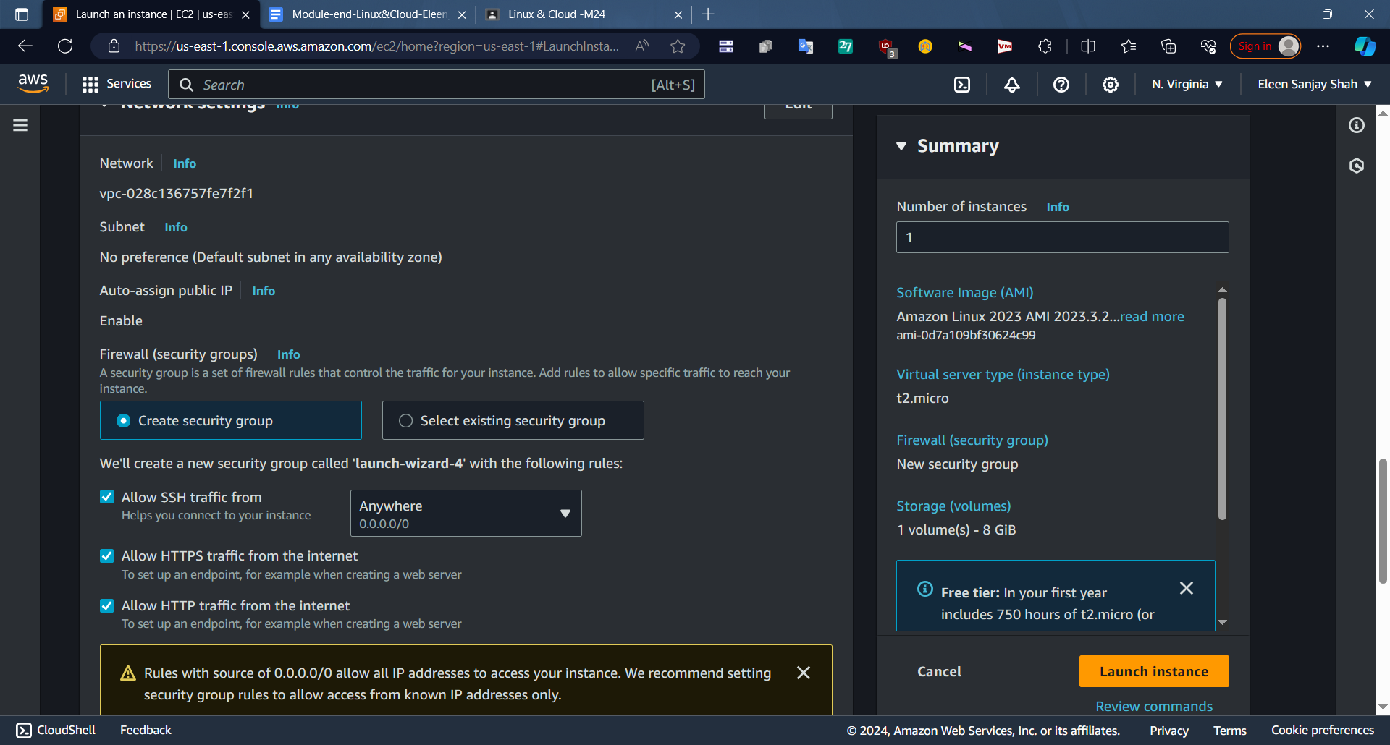

Step 9 - Click on Launch Instance

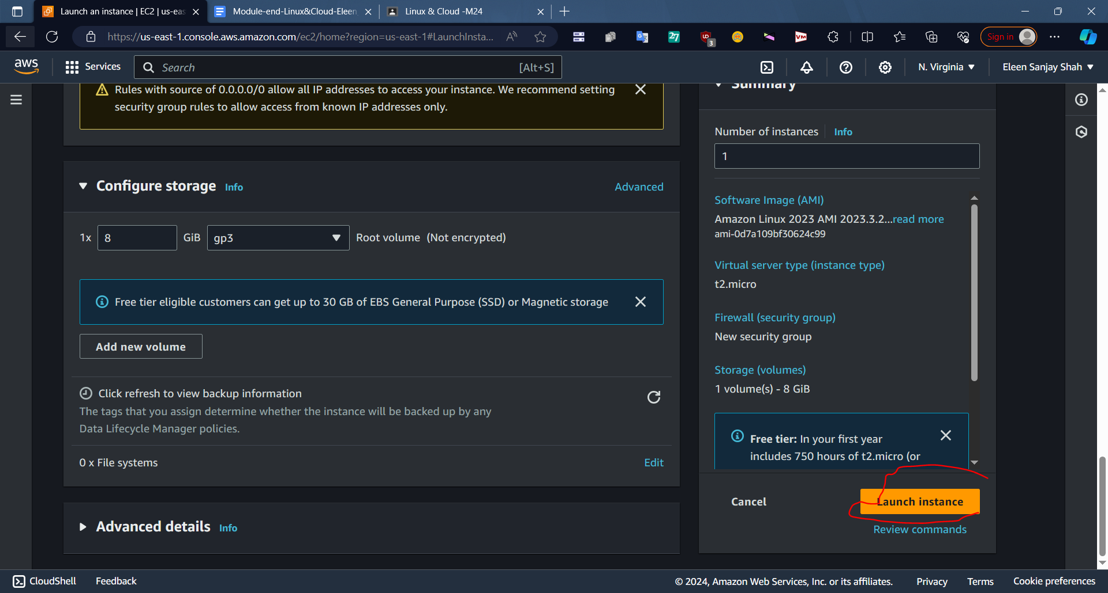

Step 10 - Click on Instances after your instance is created succesfully

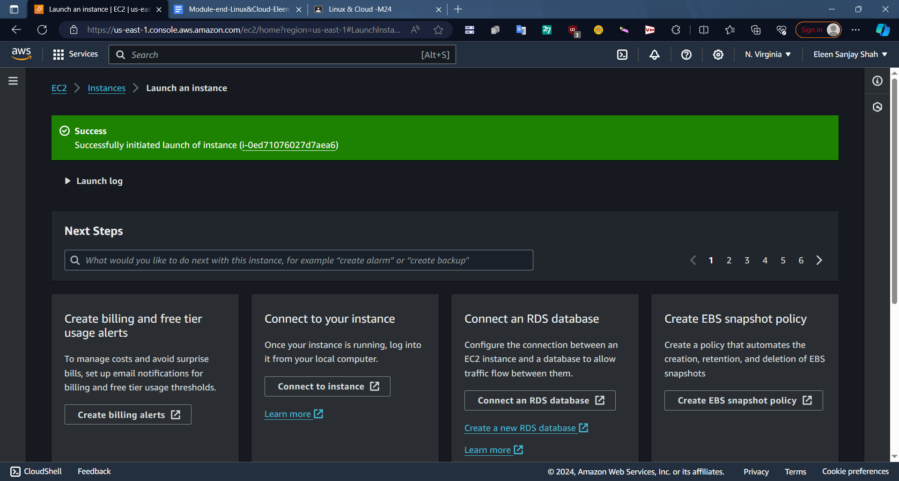

Step 11- You can see your instance ID and PublicIPv4 address and other attributes.

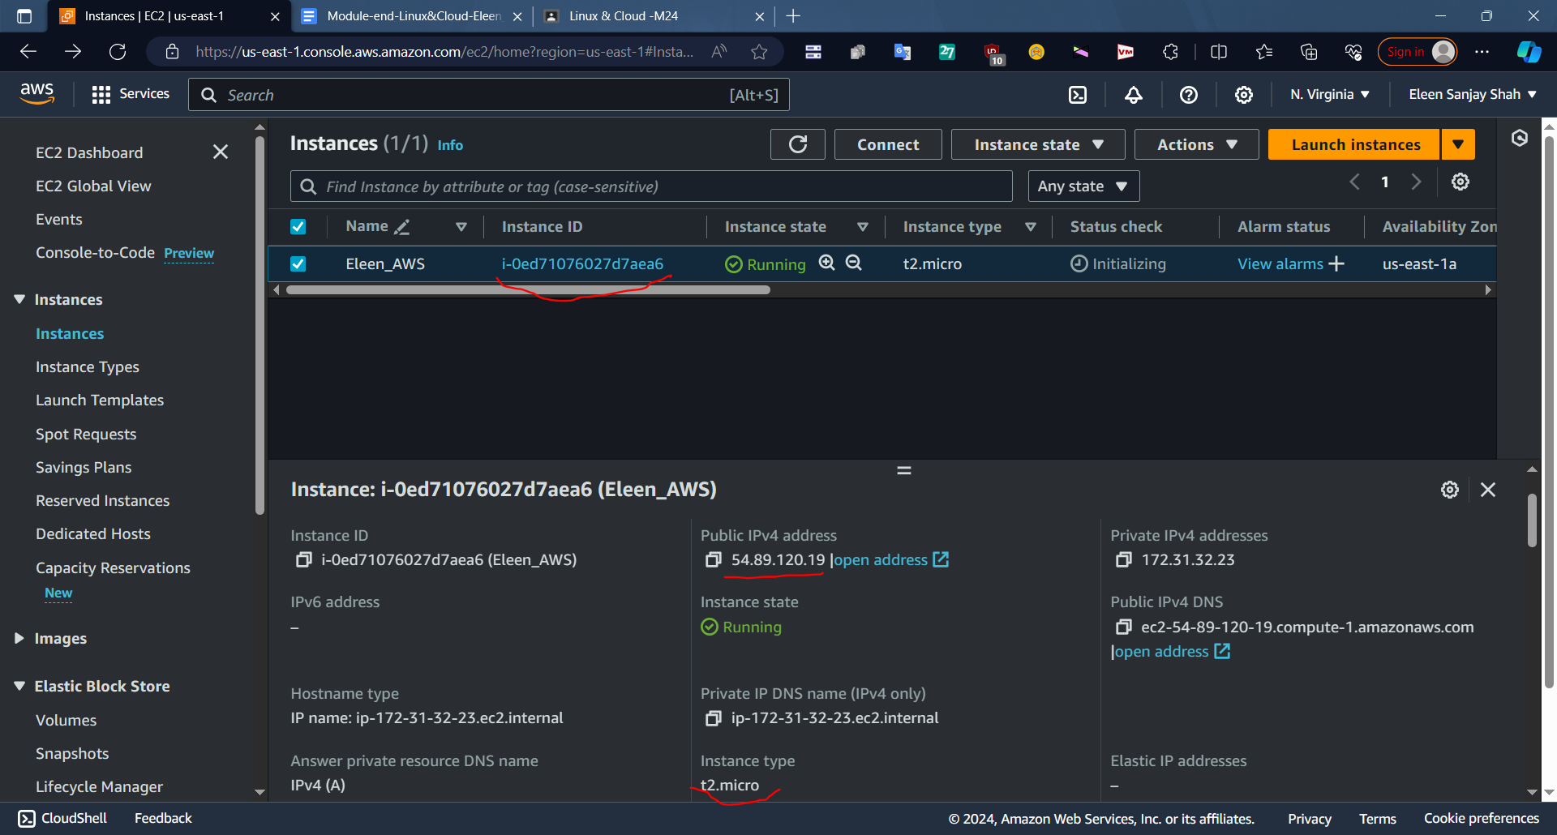

Step 12 - Open Putty and type hostname ec2-user@IP address

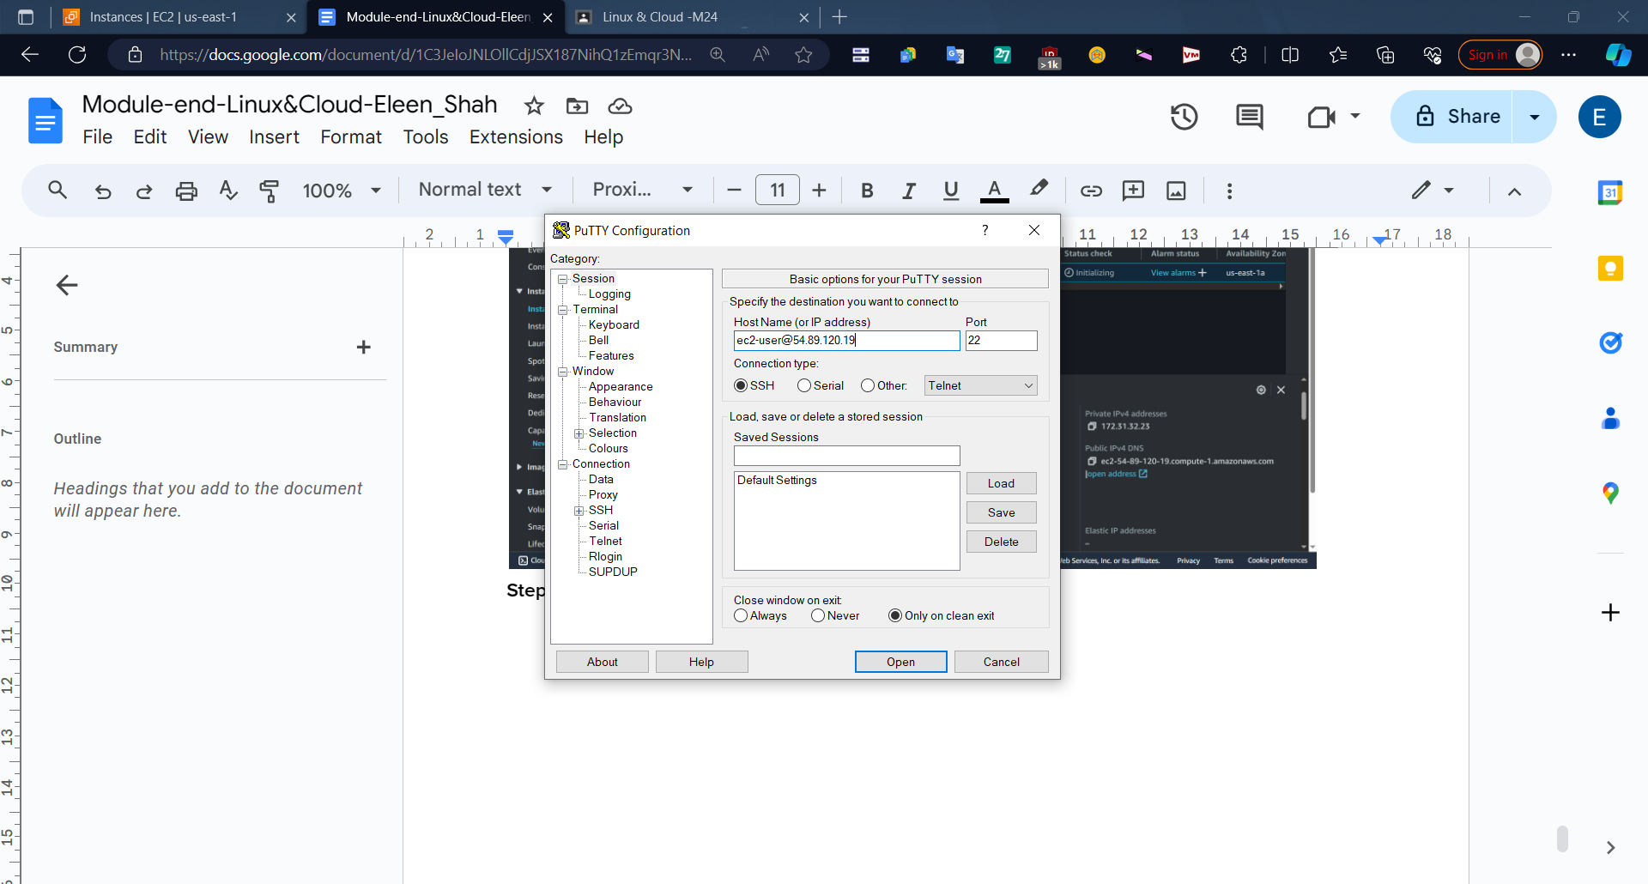

Step 13 - Go to SSH>Auth>Credentials and select the private key pair which you created.

Click on Open. 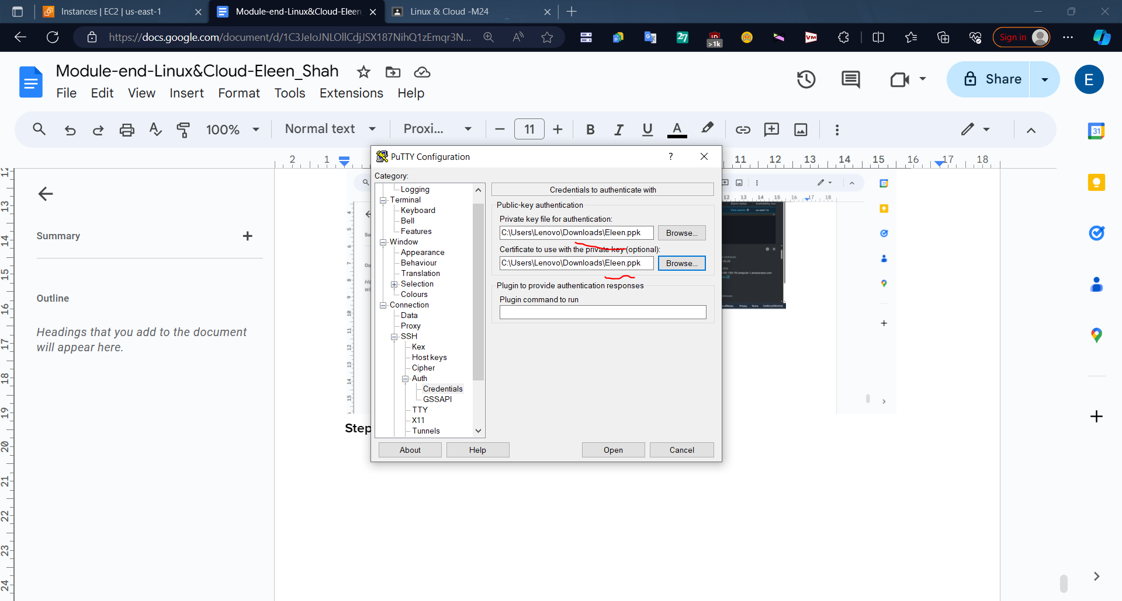

Step 14- Putty terminal will open. In dialog box, click accept

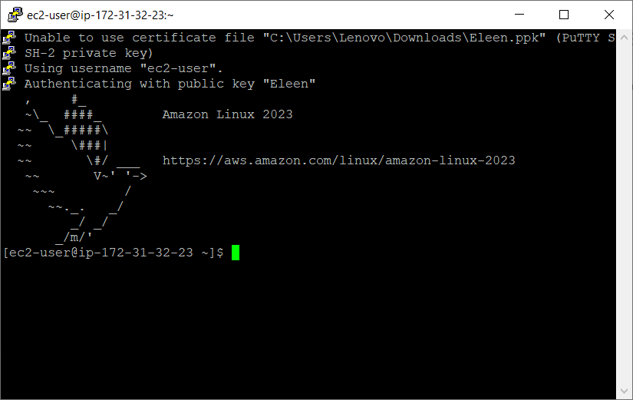

Step 14-

Write commands

sudo -i #to give root user access

yum update -y #to update packages

yum install httpd -y #to install httpd package

systemctl start httpd #start httpd demon

systemctl status httpd #status of httpd

systemctl enable httpd #to allow httpd to accept traffic

Cd /var/www/html #Go to html folder

Vi index.html #Create a html file

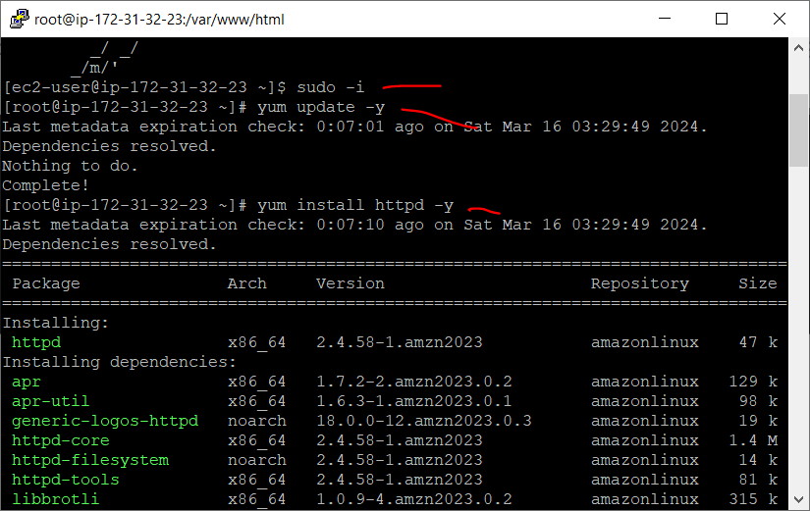

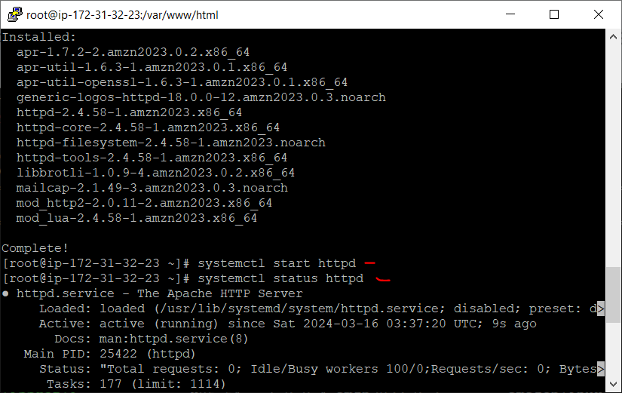

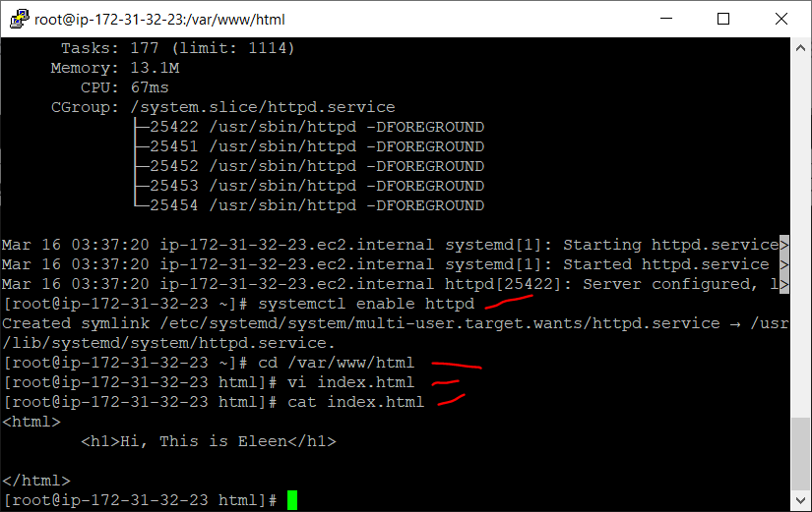

Step 15- Write HTML Code

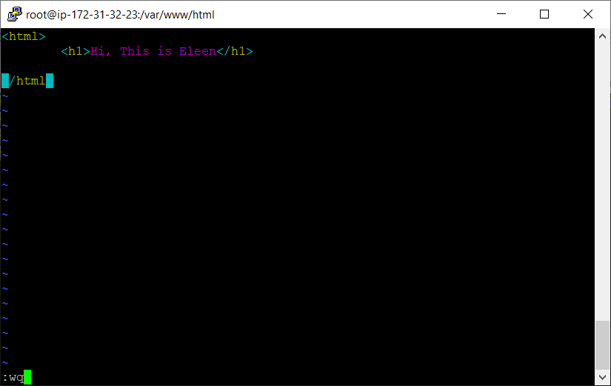

Step 16 - Write Public IPV4 address of your EC2 instance in browser. Done!!!

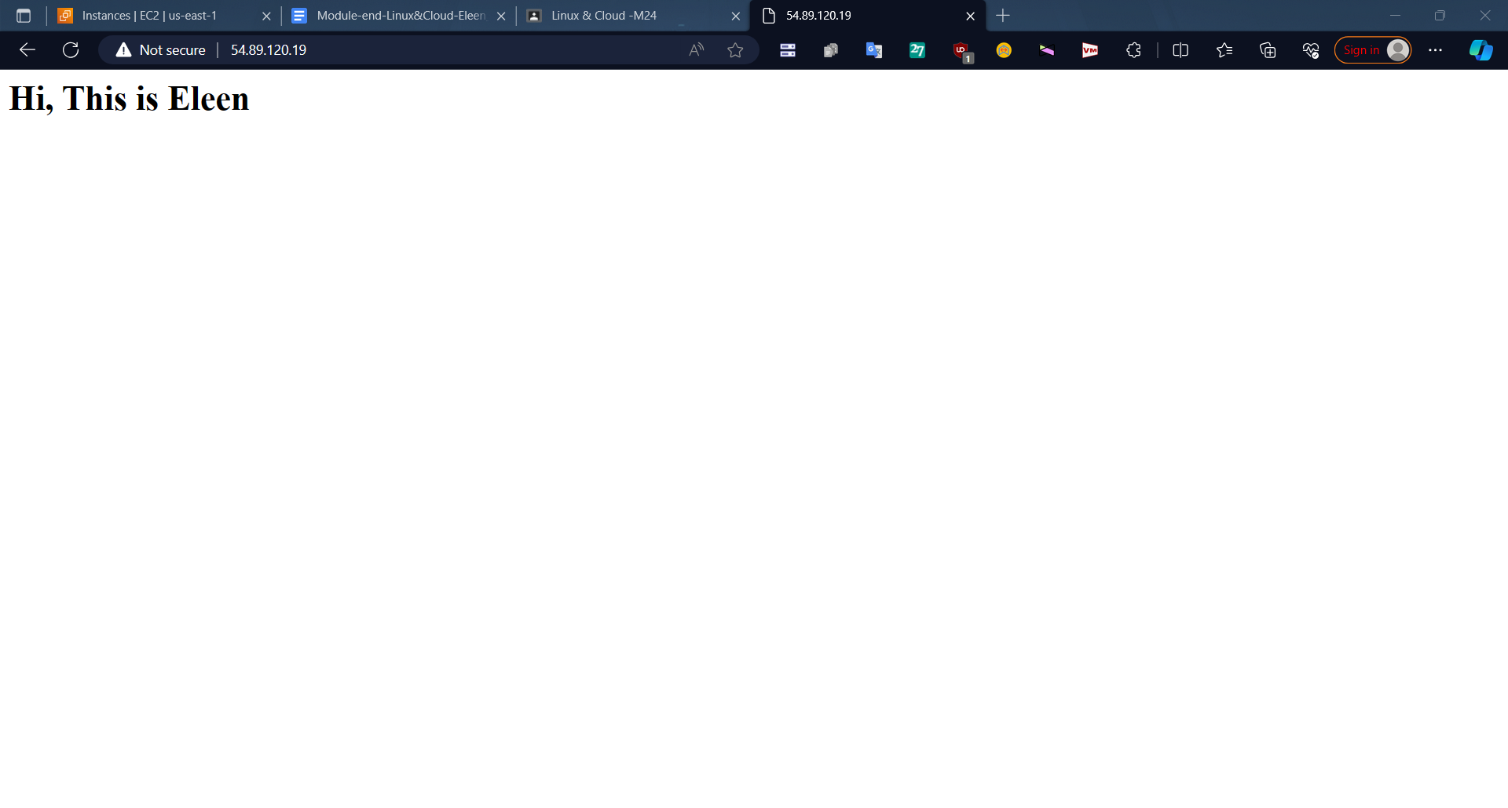

2] VPC

Step1 - First go to VPC Dashboard and click on Create VPCs

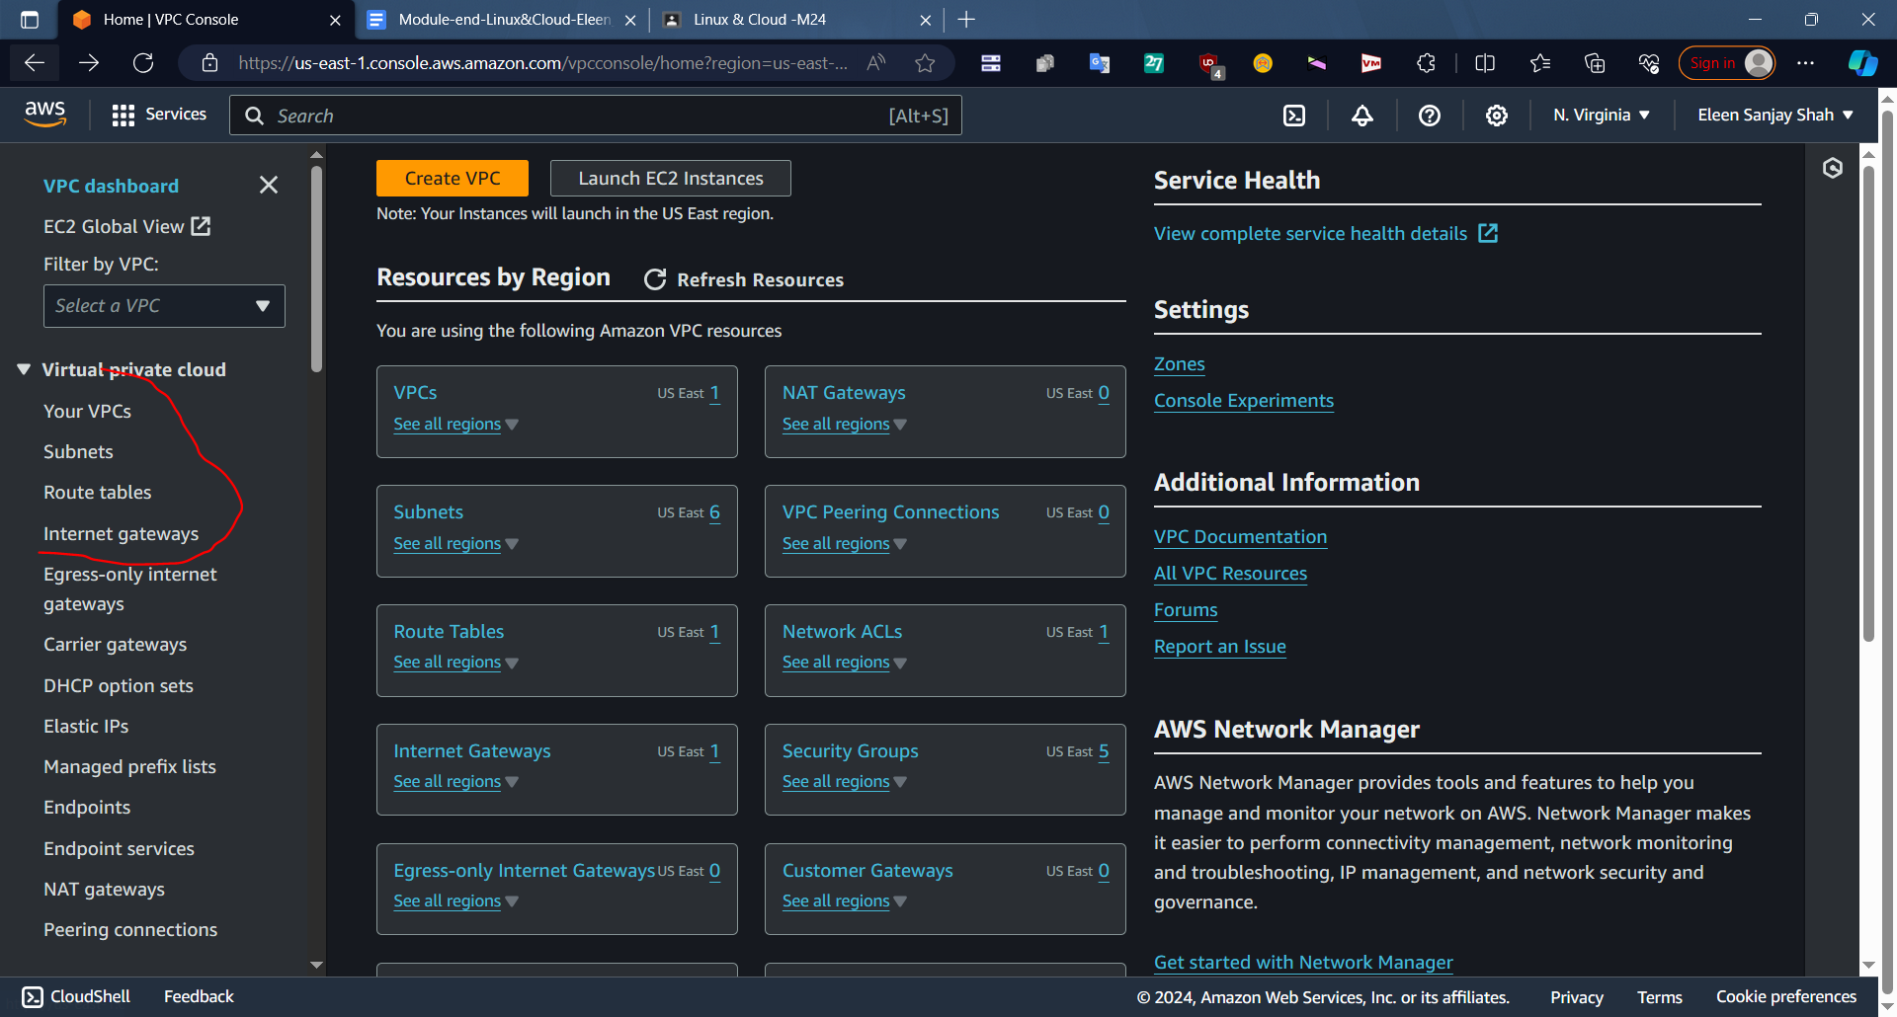

Step2 - Click on Create VPC

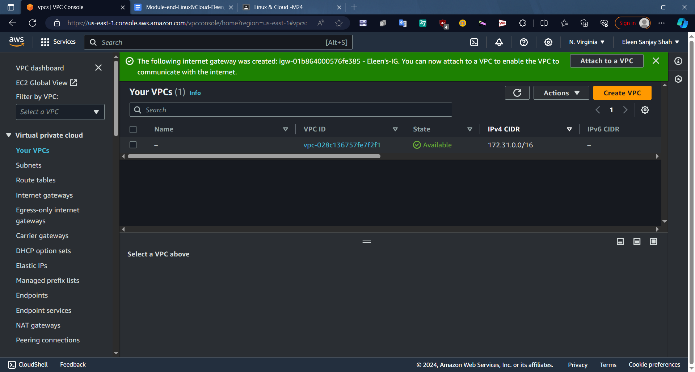

Step3 - Give VPC name and type IPV4 address

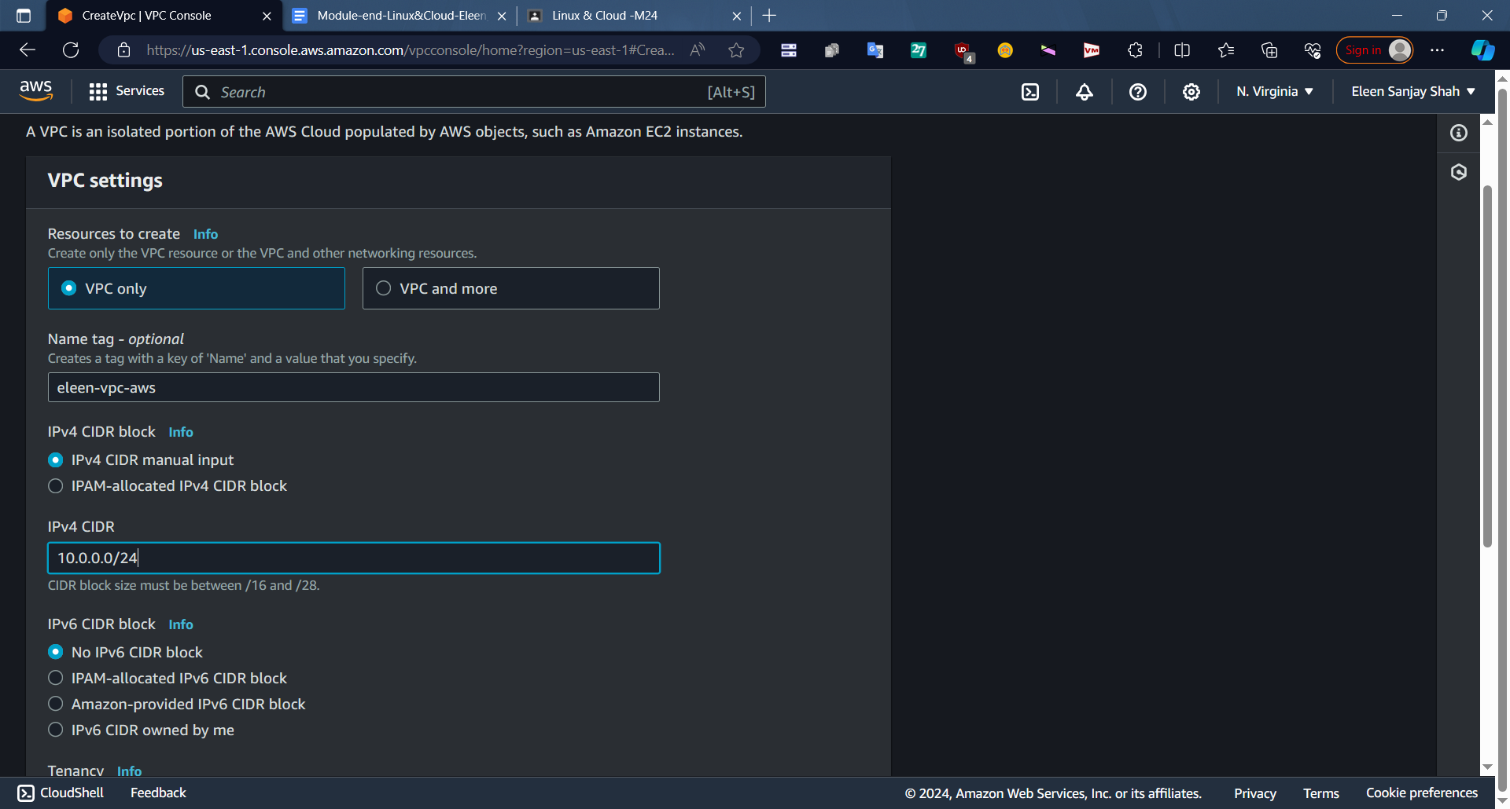

Step 5 - nNow our vpc is created but there are no associations , subnets .

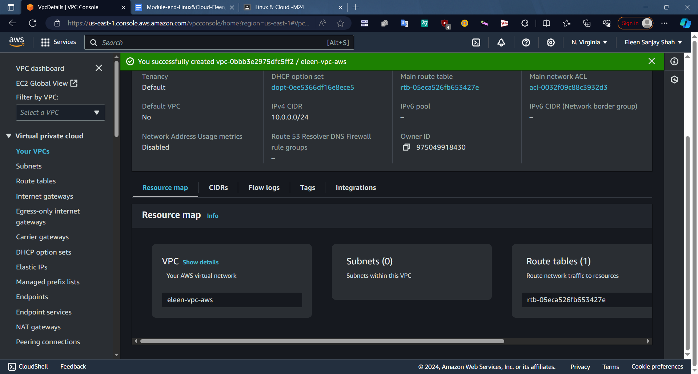

Step6 - Create Internet Gateway

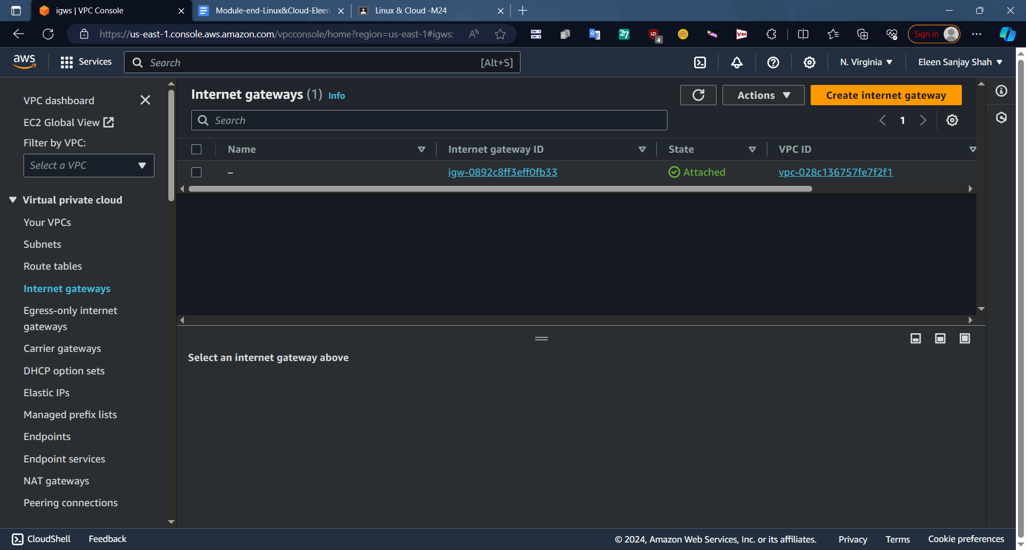

Step 7 - Give Name and click on Create IG also attach to VPC which you created

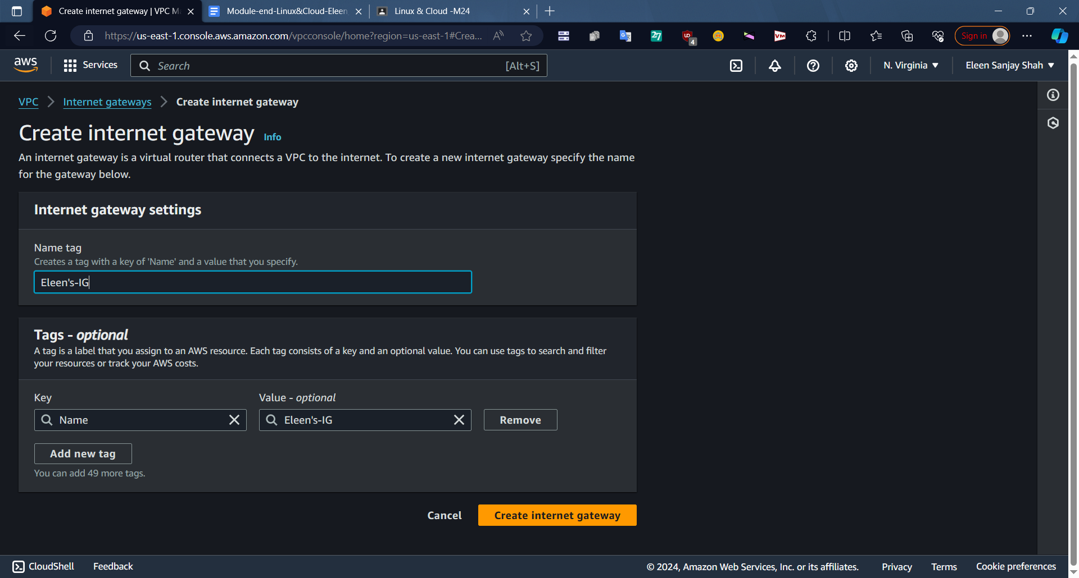

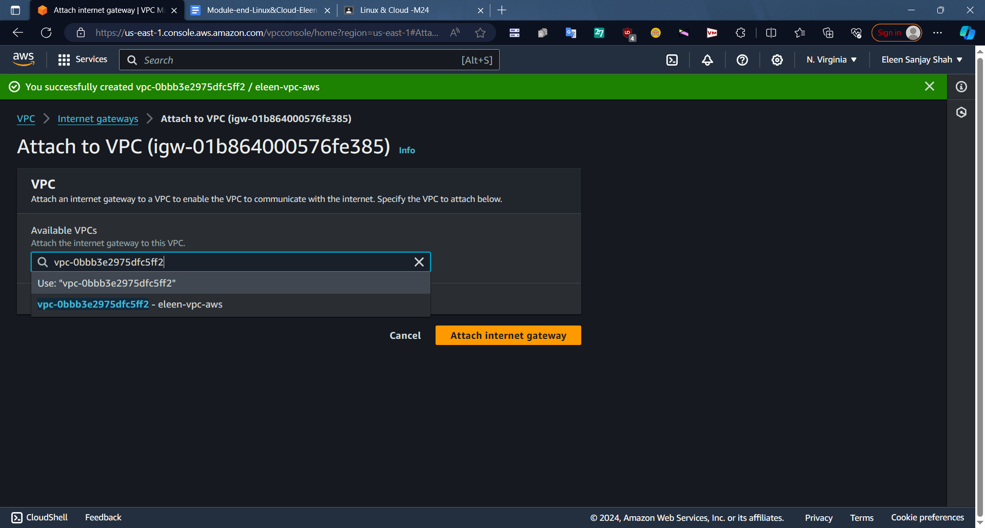

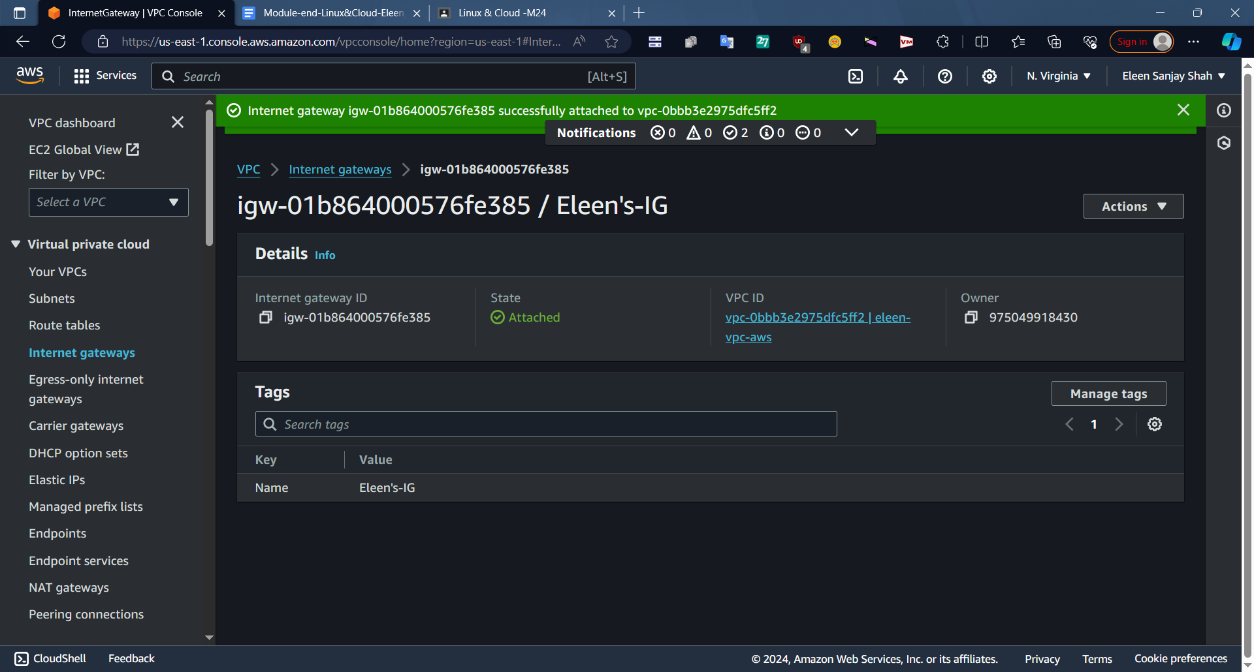

Step 8 - Create Subnets

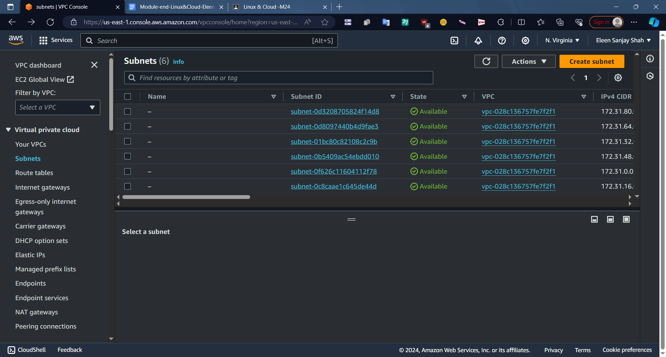

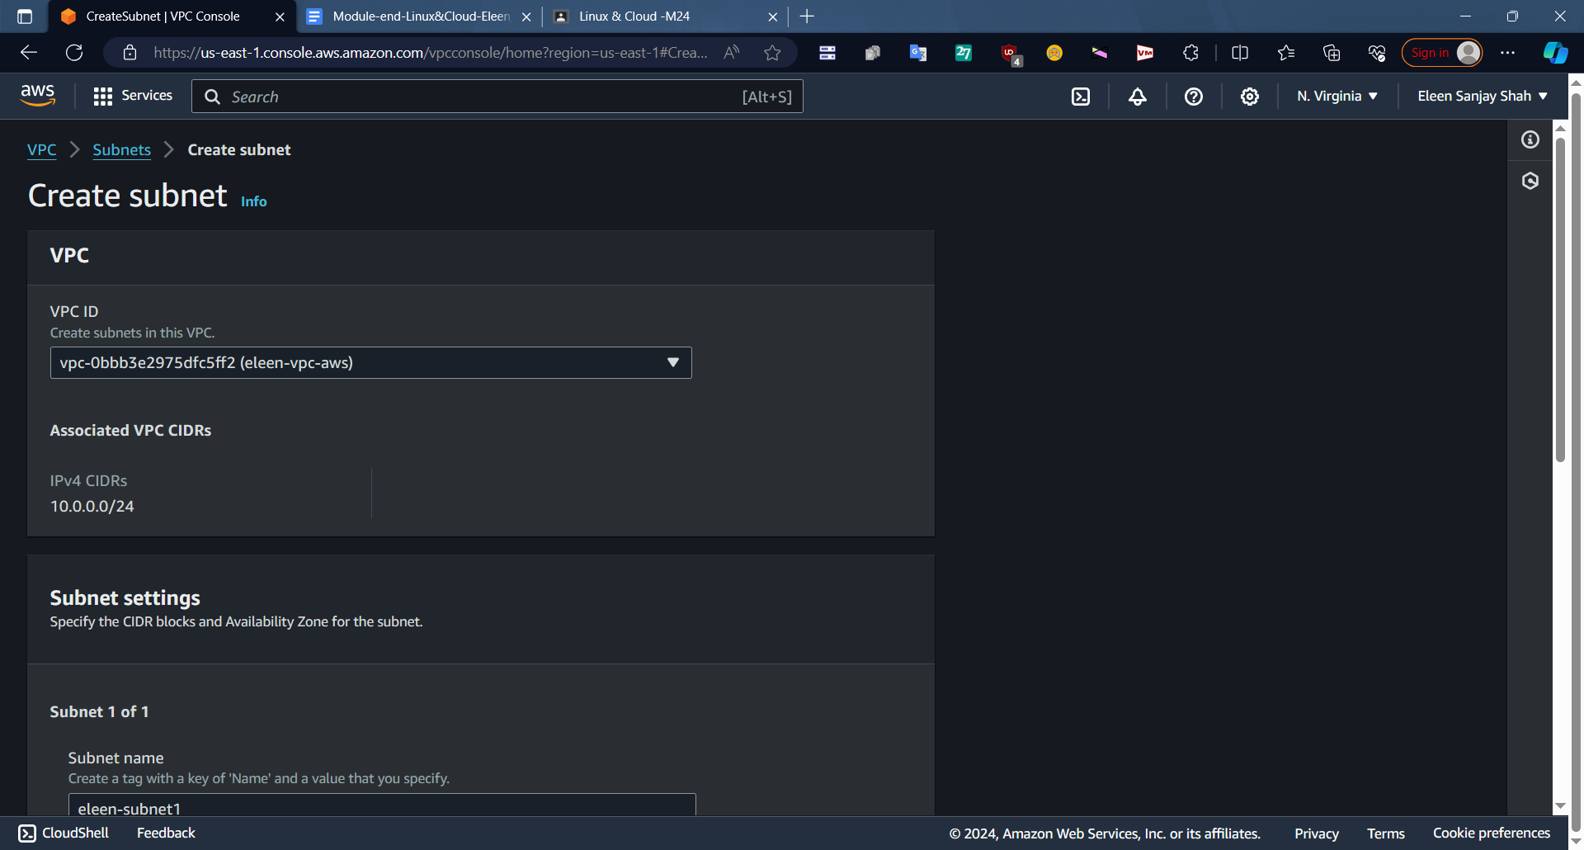

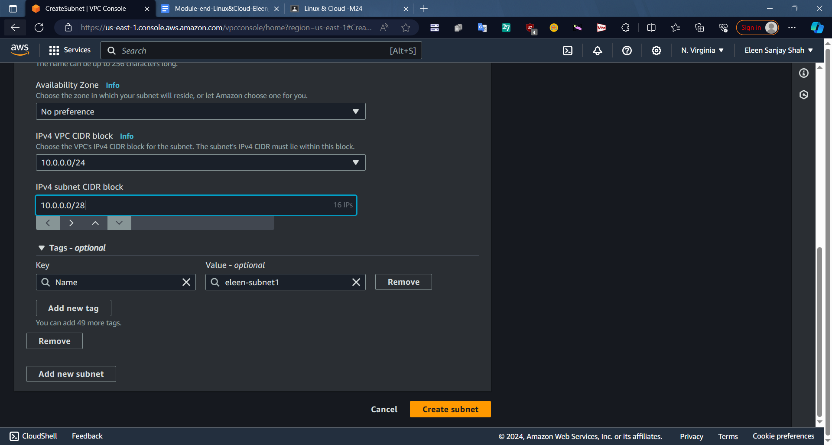

Step 8 - Create Route table

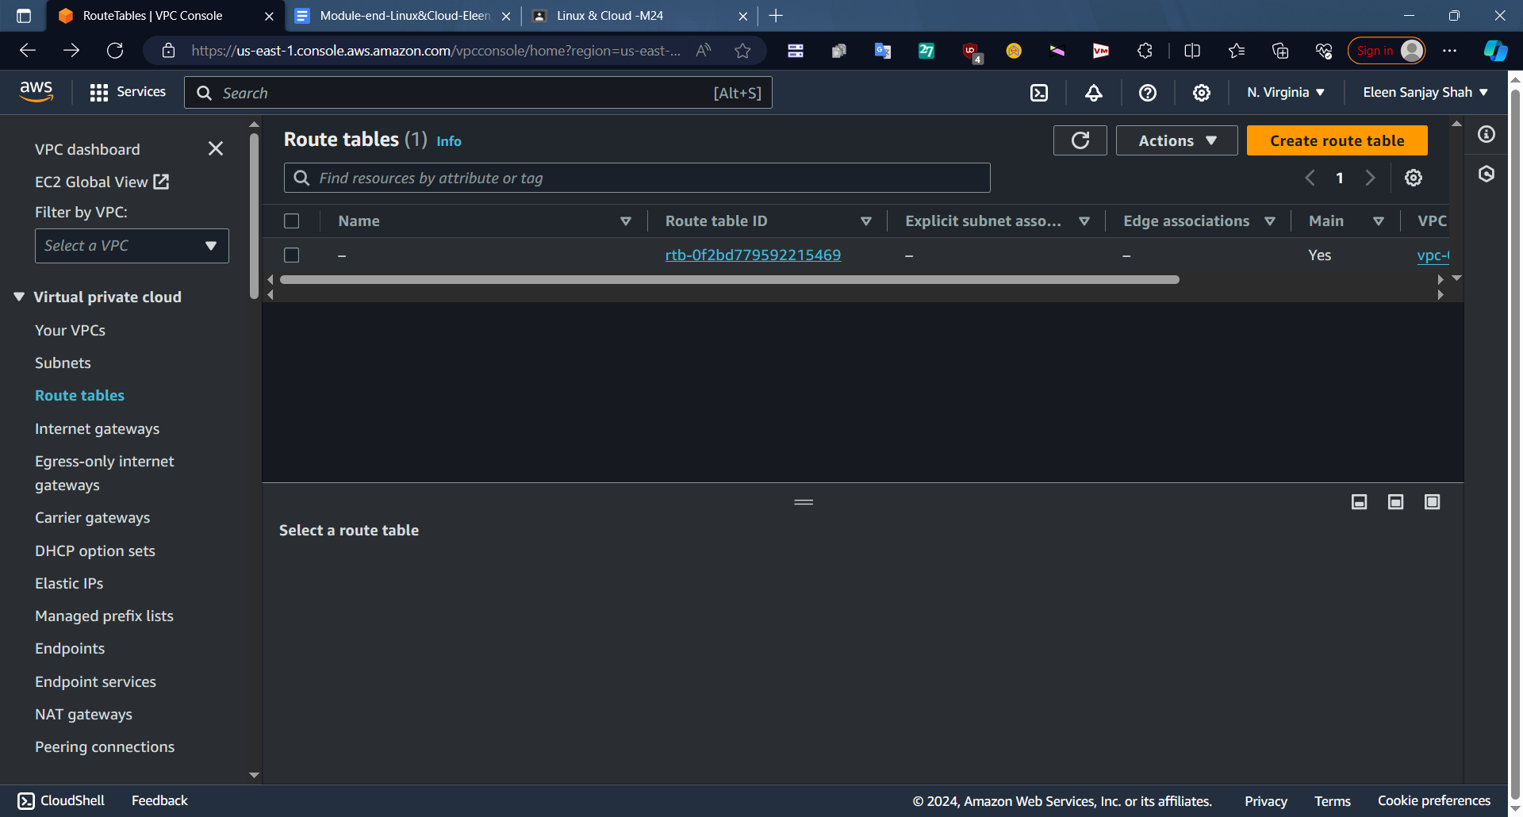

Step 9 - Give name to route table

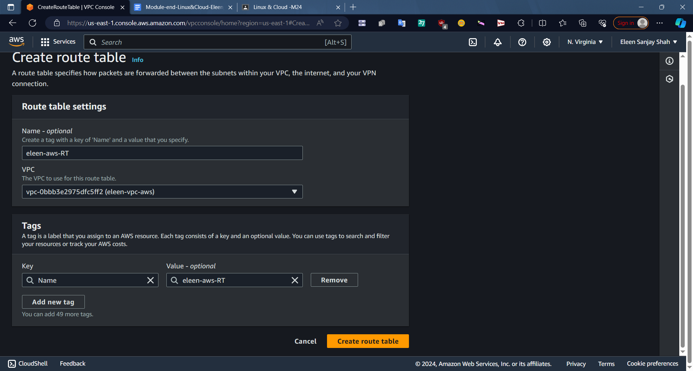

Step 10 - Click on Actions >Edit Subnet Associations

Step 11 - Select 2 subnets you created and save associations

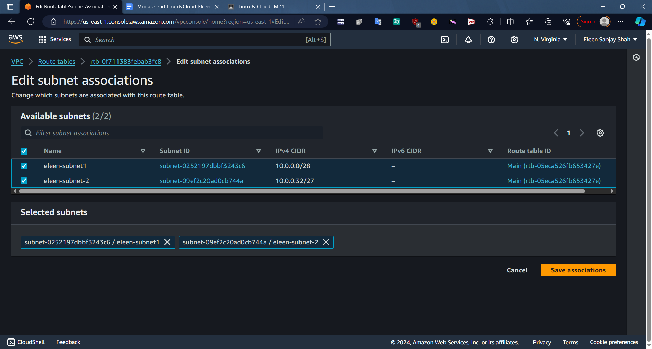

Step 12 - Go to Actions > Edit Routes > Connect to IG you created and save changes.

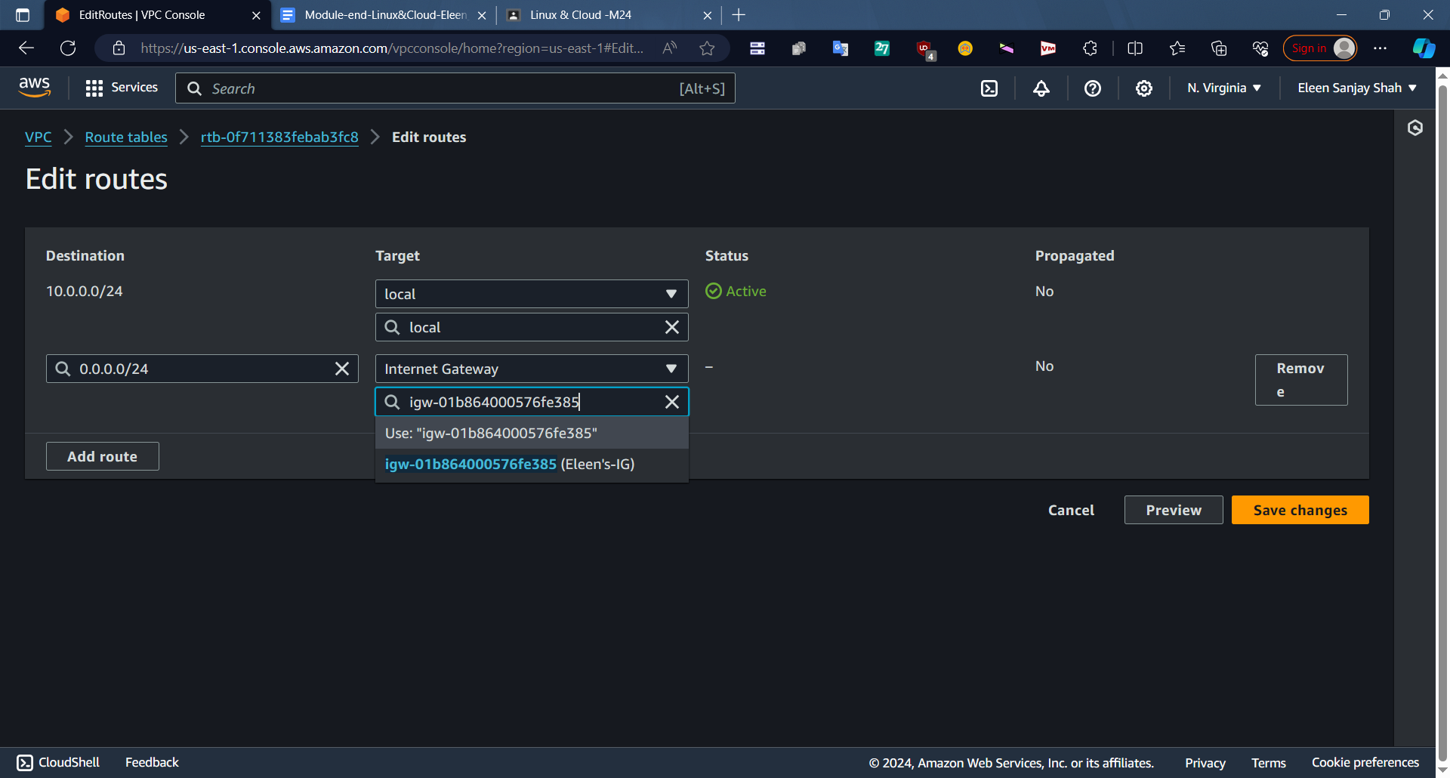

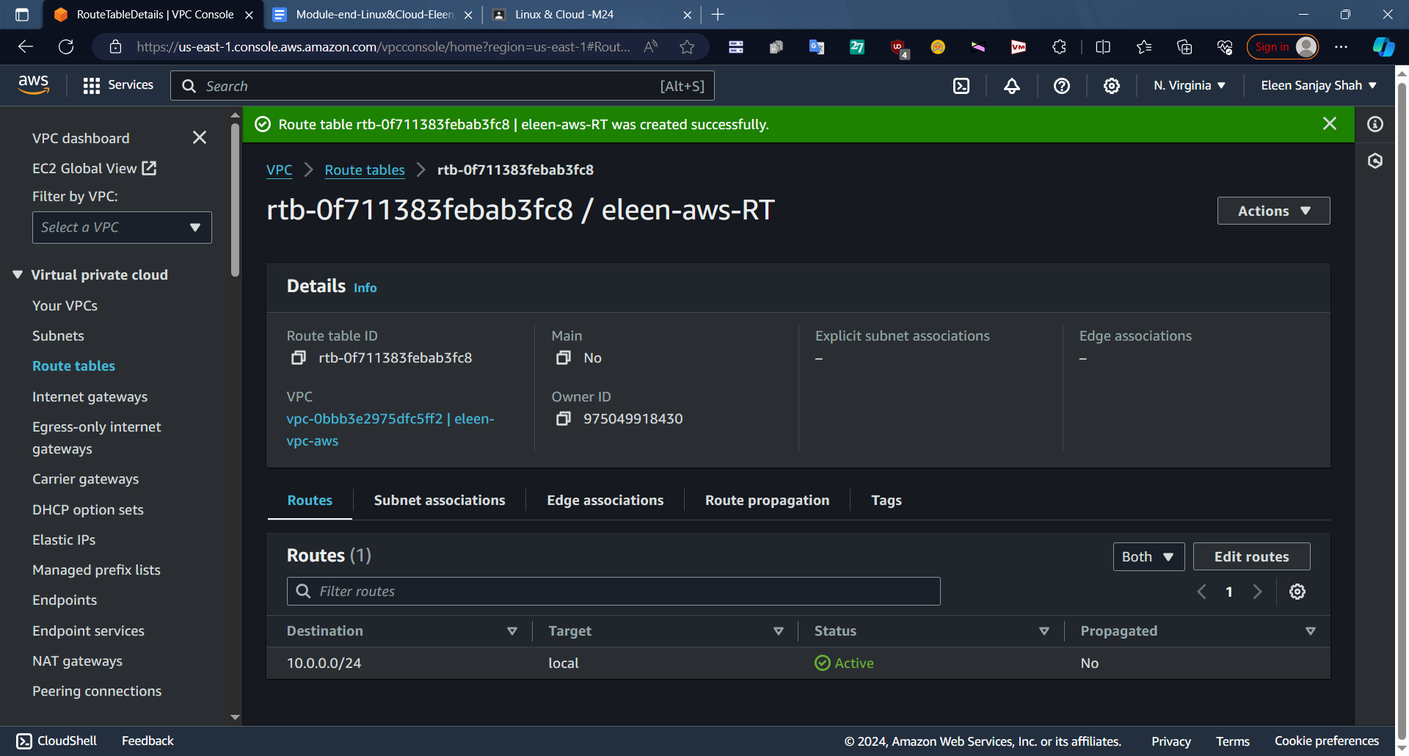

VPC Resource Map

